Cloud Computing

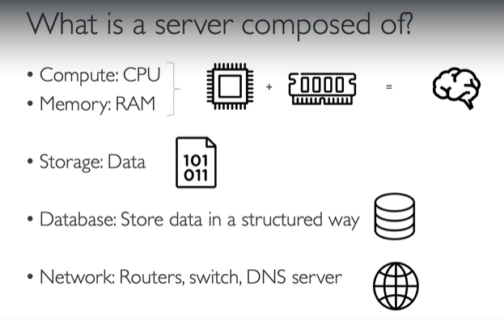

Servers are computer or system can usually handle requests and send responses(resources, data, services, or programs) to clients following the client-server model.

Network, Router, Switch

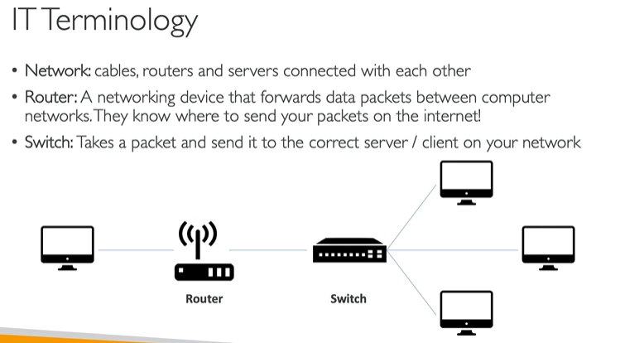

What is Cloud Computing?

Cloud computing is the on-demand delivery of IT resources over the internet with primarily pay-as-you-go pricing. With cloud computing, companies do not have to manage and maintain their own hardware and data centers. Instead, companies like Amazon Web Services (AWS) own and maintain data centers and provide virtual data center technologies and services to companies and users over the internet.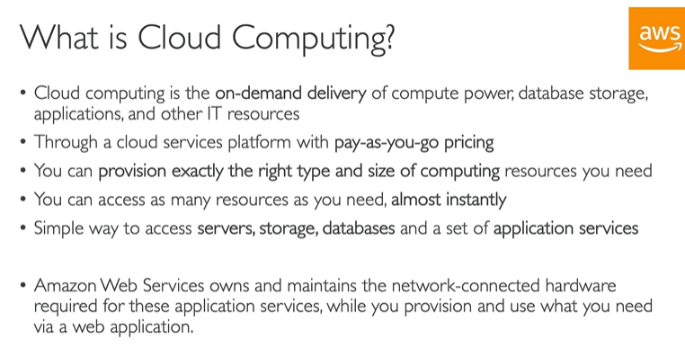

Deployment Models Of Cloud

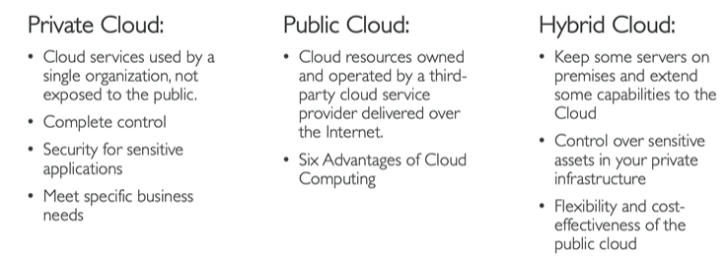

1. On-premises

Before the cloud, companies and organizations hosted and maintained hardware such as compute, storage, and networking equipment in their own data centers. They often allocated entire infrastructure departments to take care of their data centers, which resulted in costly operations that made some workloads and experimentation impossible.

As internet use became more widespread, the demand for compute, storage, and networking equipment increased. For some companies and organizations, the cost of maintaining a large physical presence was unsustainable. To solve this problem, cloud computing emerged.

1. Cloud Computing
2. Hybrid Model

A third option is a hybrid deployment. This type of deployment is a way to connect infrastructure and applications between cloud-based resources and existing resources that are not located in the cloud. The most common method of hybrid deployment between the cloud and existing on-premises infrastructure connects cloud resources to internal systems to extend and grow an organization's infrastructure into the cloud.

Characteristics Of Cloud Computing

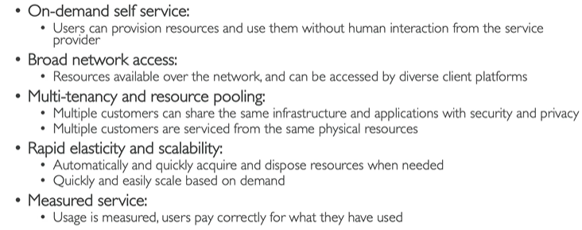

Advantages Of Cloud computing

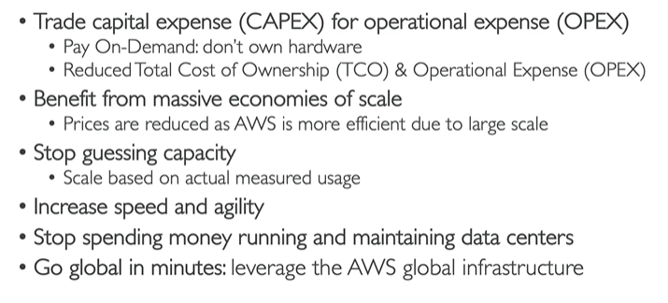

Types/Model Of Cloud Computing

1. IaaS

Iaas is also known as Hardware as a Service (HaaS). It is one of the layers of the cloud computing platform. It allows customers to outsource(obtain (goods or a service) by contract from an outside supplier) their IT infrastructures, such as servers, networking, processing, storage, virtual machines, and other resources. Customers access these resources on the Internet using a pay-as-per-use model.

In traditional hosting services, IT infrastructure was rented out for a specific period of time, with pre-determined hardware configuration. The client paid for the configuration and time, regardless of the actual use. With the help of the IaaS cloud computing platform layer, clients can dynamically scale the configuration to meet changing requirements and are billed only for the services actually used.

IaaS is offered in three models: public, private, and hybrid cloud.

1. Paas

**VIRTUAL MACHINES**